Coffee Shop Analysis Using Microsoft Excel

The aim of this project is to create insights and dashboard for a coffee sale. Transform the raw data (uncleaned data) into meaningful data (cleaned data) by using various functions in excel. By using this cleaned data create insights and interactive dashboard. In this project, I analyzed how coffee sales are varying each year from 2019 to 2022.

Steps include:

1. Data Gathering
2. Data Cleaning
3. Filtering, Sorting, Various Excel Functions
4. Pivot Tables & Pivot Charts
5. Data Visualization
6. Dashboard Creation

Dashboard:

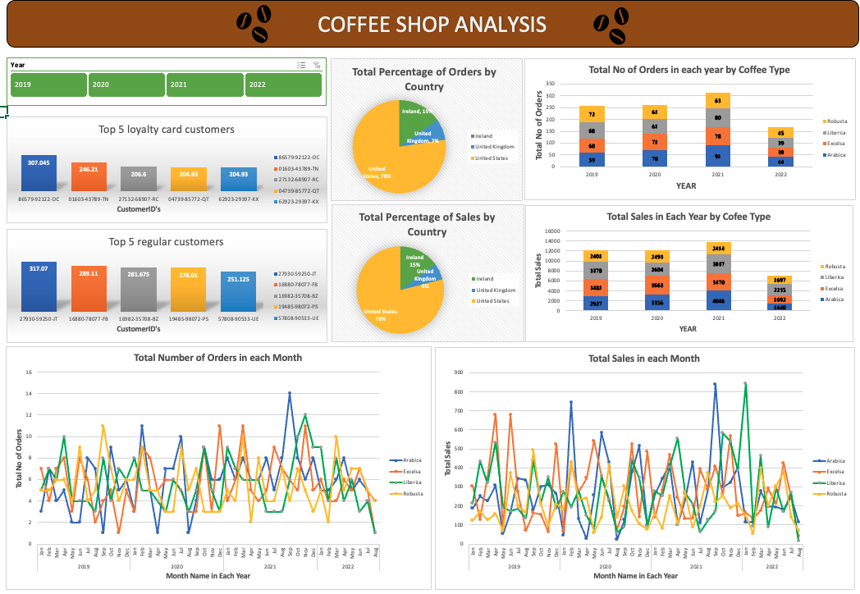

**Data Gathering:**

The dataset can be found on this below GitHub link.

<https://github.com/mochen862/excel-project-coffee-sales>

For reference, you can check Mo Chen YouTube Channel.

**Data Cleaning:**

Here, we check the data thoroughly whether the data contains any Null values, blanks, errors and remove duplicate rows.

Make sure data is consistent and clean with respect to data type, data format and values used.

**Various Excel Functions:**

By using various excel functions create the new columns and extract the data from the existing columns.

In this project, I used TEXT(), YEAR(), LEN(), LEFT(), RIGHT(), MID(), FIND(), VLOOKUP(), XLOOKUP(), IFS().

**Pivot Tables & Pivot Charts:**

After cleaning the data, start creating pivot tables and create appropriate pivot charts.

Country wise total number of orders. United States is in first place with 774 orders and United Kingdom is in last place with only 73 orders.

Country wise total sales. United States is in first place with $35,638.9 and United Kingdom is in last place with $2798.5.

Top5 spending customers with loyalty card. Customer ID 86579-92122-OC have loyalty card and spend highest amount compared to all other loyalty customers.

Top5 spending customers with no loyalty card. Customer ID 27930-59250-JT have no loyalty card but spend highest amount compared to all other customers with no loyalty card.

This above line graph shows us the total number of orders of each coffee type (Arabica, Excelsa, Liberica, Robusta) for each month from 2019 to 2022.

List of coffee types and the month and year of highest orders.

Coffee Type Month & Year

Arabica Sep 2021

Excelsa Dec 2020, Mar 2021, Nov 2021

Liberica Nov 2021

Robusta Sep 2019

This above line graph shows us the total sales of each coffee type for every month from 2019 to 2022.

Arabica have highest sales on Sep 2021, Excelsa have highest sales on Apr 2019 and Jun 2019, Liberica have highest sales on Jan 2022 and Robusta have highest sales on Sep 2019.

This above stacked column chart shows us the total number of orders of each coffee type in each year.

|  |  |  |
| --- | --- | --- |
| Year | Highest no of Orders | Lowest no of Orders |
| 2019 | Robusta | Arabica |
| 2020 | Excelsa | Robusta, Liberica |
| 2021 | Arabica | Robusta |
| 2022 | Robusta | Excelsa |

This above stacked column chart shows us the total sales of each coffee for every year. By using this you can easily find out which coffee type have highest and lowest sales.

|  |  |  |
| --- | --- | --- |
| Year | Highest Sale in Dollars | Lowest Sale in Dollars |
| 2019 | Excelsa | Robusta |
| 2020 | Excelsa | Robusta |
| 2021 | Arabica | Robusta |
| 2022 | Liberica | Arabica |

Slicer:

With this slicer you can filter data in all pivot tables and pivot charts.

**Data Visualization:**

**Finally, the dashboard was created by inserting all the pivot charts on a separate sheet named “Dashboard”.**